Final Report:

TITLE: EMERGENCY SOS KEYCHAIN
Team number:
Roll. no. | Name | Mobile No. | E-mail I.D.
1. | Saai krahaanth. S Ja | 8189965164 | krahaanthskprime73@gmail.com
2. | Dinesh raj.V | 8939803508 | dineshrajv2004@gmail.com
3. | Aastin.K | 7358511338 | aastin@gmail.com
4. | Bhavani.M | 9342159702 | Boldbhanu333@gmail.com
5. | Divya.K | 9789181621 | divyakasilingam164@gmail.com

Faculty mentors:
- Vanitha Mam (Mentor)

PRINCE Dr. K VASUDEVAN COLLEGE OF ENGINEERING AND TECHNOLOGY

Date:17/05/2024
Abstract:
The SOS keychain is a compact, portable device designed for personal safety and emergency assistance. Integrating modern technology with ease of use, this keychain typically features a discreet alarm system that can be activated to alert others in case of danger. Some models are equipped with GPS tracking, allowing for real-time location sharing with emergency contacts or authorities. Additionally, the SOS keychain may include functionalities such as a flashlight, panic button, and pre-programmed emergency messaging capabilities. Its small, lightweight design ensures it can be easily carried or attached to personal items like bags or keys, making it an accessible and reliable tool for enhancing personal security. Ideal for individuals of all ages, particularly those vulnerable to threats, the SOS keychain represents a proactive approach to safety, providing peace of mind in various environments.
Table of Contents
1 Introduction 2
1.1 Problem Definition 2
2 Proposed solutions/concept 2
3 Design Details 3
4 Timeline 3
5 Implementation 3
6 Conclusions 3
2 Acknowledgments 3
3 References 3

Introduction
Should contain answers to following questions.
- What is your product all about?
- An SOS emergency keychain is a compact, portable device designed to enhance personal safety by providing immediate access to emergency alerts and assistance. It typically features an alarm system that can be activated to draw attention in dangerous situations, and may also include GPS tracking for real-time location sharing, a flashlight, and a panic button.

- What is the motivation behind your product?
- The motivation behind the SOS keychain is rooted in the need for accessible and immediate personal safety solutions in a world where threats and emergencies can arise unexpectedly.

- Who will be the beneficiary of your product?

- Schoolchildren often do not have access to smartphones during school hours. However, emergencies can still occur when they are away from home or school. The keychain should provide a solution for these situations.

- What is the innovative aspect in your product?

- Limited to Smartphones: The SOS keychain concept appears to be restricted to smartphone usage. This limitation can pose challenges in situations where individuals do not have access to smartphones.
- Potential Kidnapping Scenario: In case of a kidnapping, perpetrators might separate the affected individual from their smartphone, preventing them from using the SOS feature. It's essential to consider alternative methods for alerting authorities or seeking help.
- Health Emergencies for the Elderly: Older individuals may experience health emergencies where they need immediate medical assistance. Relying solely on smartphones may not be practical for this demographic.
- School Children's Usage: Schoolchildren often do not have access to smartphones during school hours. However, emergencies can still occur when they are away from home or school. The keychain should provide a solution for these situations.

Problem Definition
An SOS emergency keychain is a compact, portable device designed to enhance personal safety by providing immediate access to emergency alerts and assistance. It typically features an alarm system that can be activated to draw attention in dangerous situations, and may also include GPS tracking for real-time location sharing, a flashlight, and a panic button. This keychain is small enough to be easily carried or attached to personal items, making it a convenient and reliable tool for individuals to quickly summon help in emergencies.

Conceptual Designs

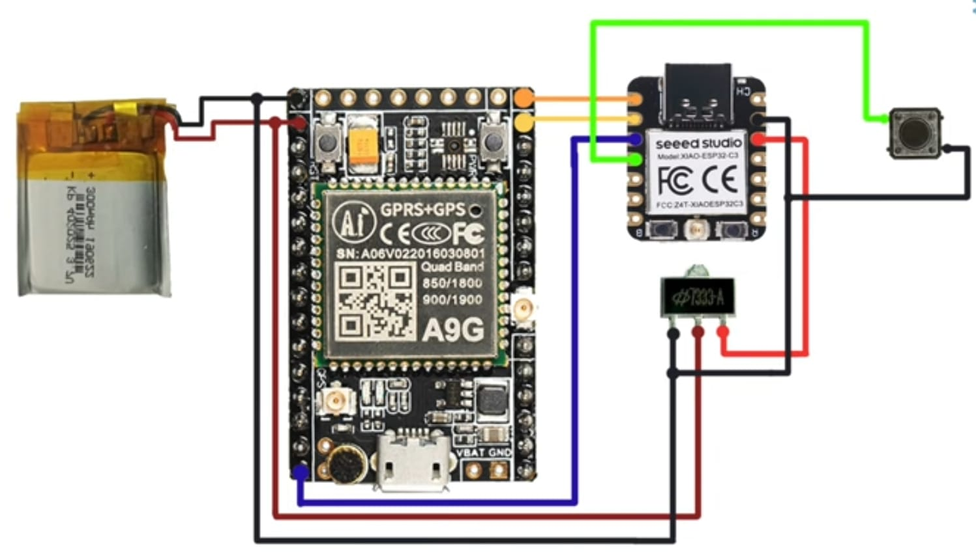

Design Details
1. Compact and portable design for easy carrying.
2. User-friendly interface for quick and intuitive operation.
3. Clear and prominent SOS button for immediate emergency activation.
4. Robust and durable construction to withstand harsh conditions.
5. GPS location sending functionality for precise location identification.
6. Long-lasting battery life to ensure reliable usage during emergencies.
7. Integration with voice transmitting device to establish the current situation.

Implementation
Our product implementation process is meticulously designed to ensure seamless integration and maximum value for our clients. We begin with a thorough needs assessment to understand client requirements, followed by a detailed planning phase where we outline key milestones and deliverables.

Next, we proceed with setup and configuration, ensuring compatibility with existing systems. Data migration is handled with utmost care to maintain integrity and accuracy. Customization is then carried out to tailor the solution to specific needs, accompanied by rigorous testing to ensure reliability.

Comprehensive training and detailed documentation are provided to equip users with the necessary skills. Upon deployment, we closely monitor performance and offer ongoing support. Continuous feedback collection and regular updates ensure the product evolves to meet changing needs, delivering sustained value over time.

Conclusions
In conclusion, the SOS emergency device stands out as a vital tool for personal safety, offering features such as GPS tracking, an SOS alert button, two-way communication, and long battery life. Its robust design ensures durability, while the integrated mobile app provides real-time monitoring and configuration options. With rigorous testing and compliance with data security standards, this device promises reliability and peace of mind for users in emergencies. Its comprehensive support and ease of use make it an essential addition to personal safety measures.

Contributions
List the contributions of each member of the team.
Saai-product design
Dinesh-soldring
Bhavani-feature designing
Divya-Testing
Aaustin-Monitoring

Acknowledgments
Gratitude to Mentors: I am immensely thankful to Vanitha Mam for their expert guidance and persistent support throughout this project. Their wisdom and encouragement were pivotal in overcoming the challenges faced during my research.

References
This is the Database of sos keychain:
https://forums.macrumors.com/threads/what-is-sosdatasource-ak-in-keychain.2116368/
This is the model of sos keychain for Reference:
https://selfdefensekeychainstore.com/products/mini-sos-130-db-self-defense-keychain-alarm

